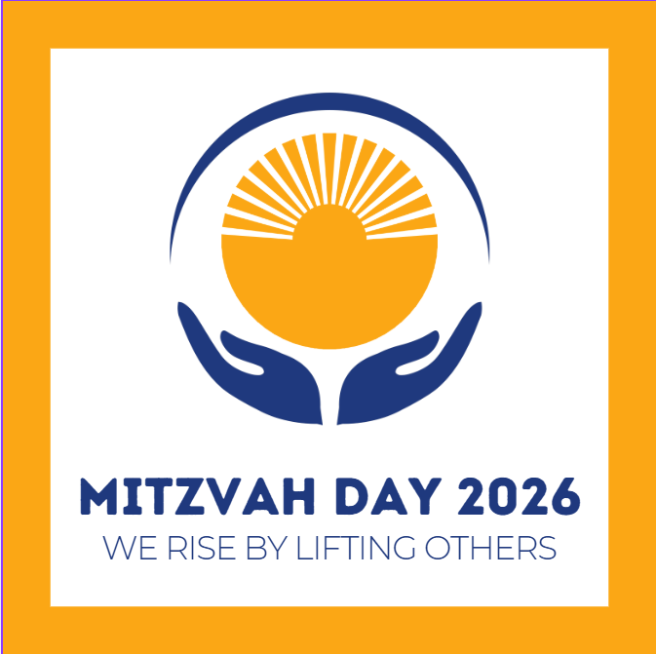

Mitzvah Day 2026
Sunday, March 22
9:00am - 4:00pm

PROGRAMMING DURING RELIGIOUS SCHOOL
9:00 – 9:30 Tefilah
9:30 – 10:00 Storytime with Lois – Grades Pre-K/K
9:30 – 9:50 Prepare bagged lunches for Corona SDA & gift bags for seniors – 1st Grade
9:55 - 10:15 Prepare bagged lunches for Corona SDA & gift bags for LaGuardia CARES – 6th Gr
10:00 - 10:15 Storytime with Bertie – 1st Grade
10:15 - 10:25 Prepare bagged lunches for Corona SDA & gift bags for seniors – 4th Grade
10:20 – 10:40 Prepare bagged lunches for Corona SDA & gift bags for LaGuardia CARES – 7th Gr
10:30 – 10:45 Prepare gift bags for seniors – Grades Pre-K/K
10:35 - 10:55 Prepare bagged lunches for Corona SDA & gift bags for seniors – 5th Grade
10:30 – 11:00 “Brighten a Child’s Day with Play and Positive Energy”– Facilitated by Andrea Campbell of Corona Family Residence – 2nd/3rd Grades ◊ Donate gently used toys and make motivational greeting cards for families living in temporary housing
11:00 – 11:20 Prepare bagged lunches for Corona SDA & gift bags for seniors – 2nd/3rd Grades
11:00 – 12:00 “Helping the Earth and Kids”– Facilitated by Temple member Sarah Maldonado, Former Education Director – 4th Grade
◊ Donate gently used toys and learn other ways to be “eco-forward”

“Caring for our Immigrant Neighbors in Need – Facilitated by Carmen Gutierrez, Director of Immigration Services, Queens Community House (QCH) – 5th Grade
◊ Assemble hygiene kits and make cards for families living in temporary housing
“How to be an Upstander” – Facilitated by Alphonso Christian Smith, Director of Youth Initiatives, NYC Commission on Human Rights – 7th Grade
11:15 – 12:00 “Service and Support Dogs in Action” – Facilitated by Temple member Karen Eisenstadt and her dog Julep – 6th Grade

MORNING
PROGRAMS FOR ADULTS AND TEENS
9:00 – 10:00 Bagels and coffee
9:30 – 3:30 Blood Drive (open to the public)
Gift of Life Stem Cell Registration (18-35 year olds, open to the public)
10:00 - 12:00 How Will YOU Lift Others?
◊ Donate blood – NY Blood Center drive continues until 3:30
◊ Swab for Stem Cell Donor Registration – Gift of Life drive continues until 3:30
◊ Donate cell phones and accessories to help victims of domestic violence and the planet –National Domestic Violence Hotline and Cellular Recycle
◊ Bring gently used or new toys and electronics for less fortunate children and to help the planet – Second Chance Toys/Corona Family Residence
◊ Donate and help pack children’s books – Book Fairies (morning only)
◊ Stuff bears and hearts for hospitalized children
◊ Bead bracelets and necklaces as gifts for girls – Jem Life Church of Jamaica
◊ Crochet/Knit blankets for those in need of warmth and comfort
◊ Write cards for our troops – Eagles Up!
◊ Assemble feminine hygiene kits for immigrants living in temporary housing – Home Life Sanctuary Village 1 (QCH partner)
◊ Create cards and toiletry kits for immigrants– Home Life Sanctuary Village 1 (QCH partner)
◊ Donate tzedakah for the Yesod Mutual Aid Fund and Queens Community House
AFTERNOON
12:00 - 1:00 Community lunch for volunteers
◊ “Strengthening Neighbors. Inspiring Change.” Remarks by Ben Thomases, CEO of Queens Community House
◊ Prepare bagged lunches for Corona SDA (ToFHY/Teens, 12:00 – 12:30)
PROGRAMS FOR ADULTS, TEENS, AND CHILDREN
1:15 - 3:15 All morning activities listed above, plus:
◊ Assemble Birthday in a Bag to help shelter families celebrate – Corona Family Residence
◊ Assemble toiletry kits for our neighbors in need – Corona SDA
◊ Help clean and prep toys for donation – Second Chance Toys (ToFHY/Teens, 1:15 – 2:30)
1:45 Junior Choir departs to perform at Forest View at 2:15, followed by Atria at 3:00
2:00 Violin Youth Concert with Karen Davidowitz departs to perform at Atria at 2:15
3:30 - 4:00 End of day reflections with Rabbi Kaiserman & Cantor Pincus

